**LAB CYCLE 3**

1. Consider the schema diagram given below for the banking enterprise. Create all the given tables by properly defining the primary key and foreign key constraints.

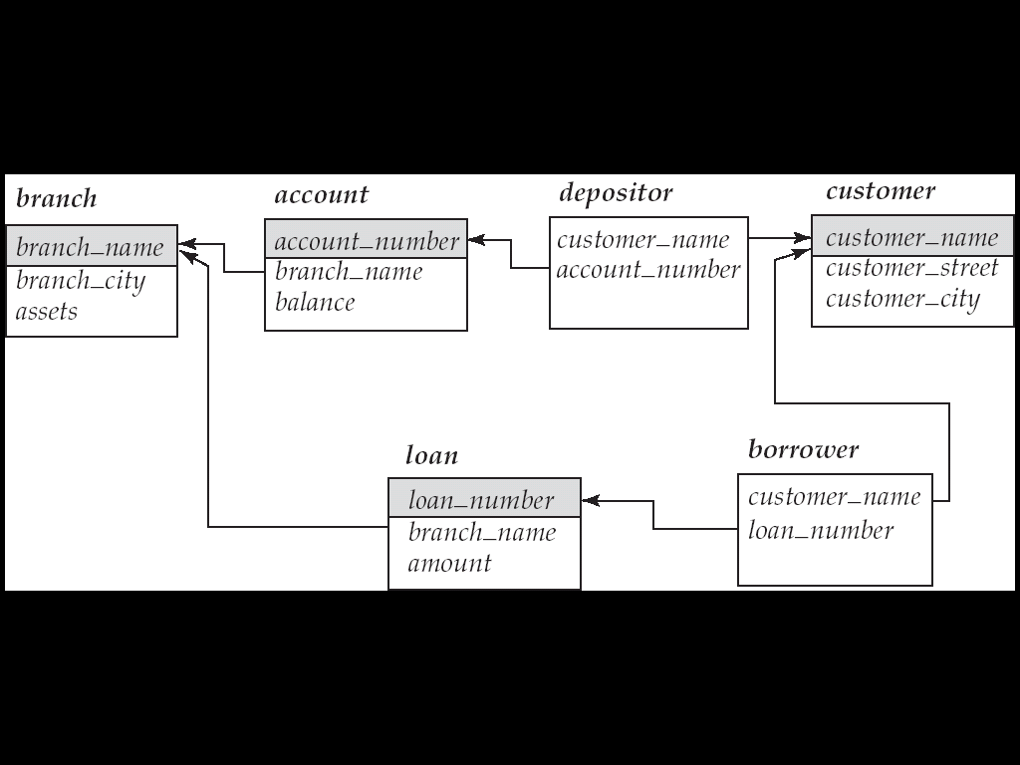

1. Insert the following values into each of the above 6 tables.

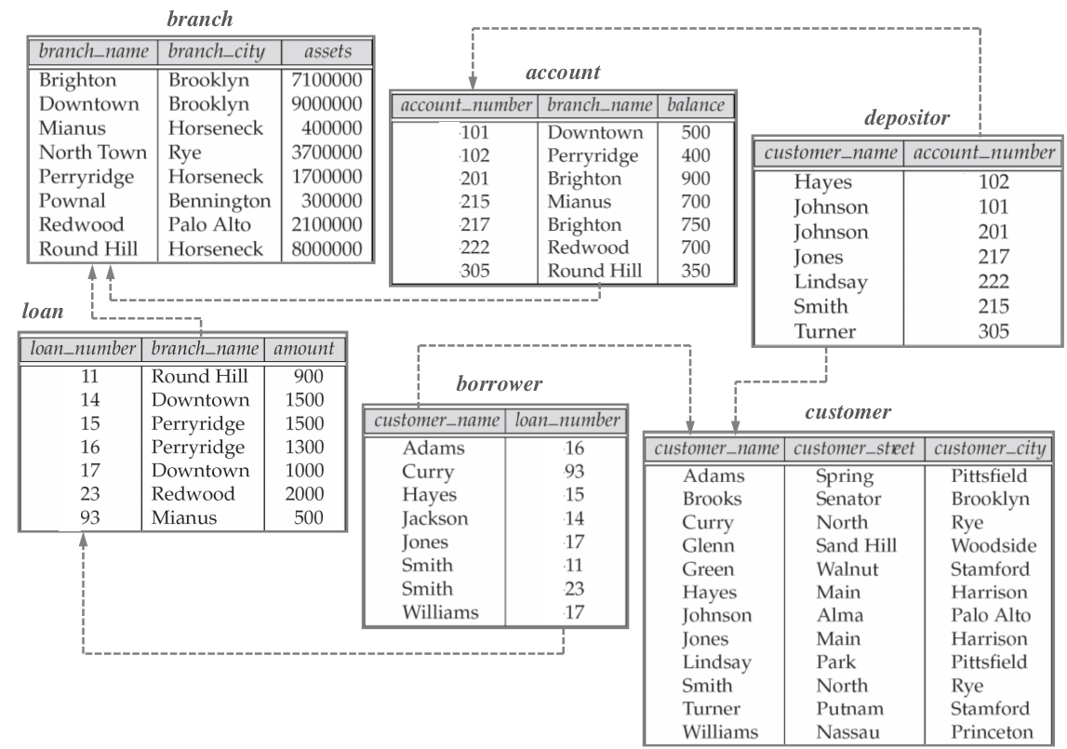

1. Find all the customers who have both a loan and an account at the Perryridge branch
2. Find the loan number of those loans with loan amounts between $90,000 and $100,000
3. Find all customers who do have a loan at the bank, but do not have an account at the bank.
4. Find the customer names and their loan numbers for all customers having a loan at some branch.
5. Select the names of customers who have a loan at the bank, and whose names are neither Smith nor Jones
6. Find the names of all branches that have greater assets than some branch located in Brooklyn.
7. Find the names of all branches that have assets greater than those of at least one branch located in Brooklyn.
8. Find the names of all customers whose street includes the substring “Main”.
9. Find all customers who have a loan, an account, or both:
10. Find the number of depositors for each branch.
11. Find the names of all branches where the average account balance is more than $1,200
12. List in alphabetic order the names of all customers having a loan at Perryridge branch.
13. Find the average account balance at the Perryridge branch.